Interpersonal Mindfulness

CONFLICT MANAGEMENT STYLES
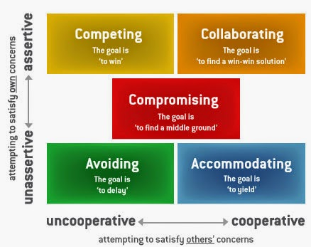
As we grow up, we typically settle on one of these three strategies as a habitual strategy for dealing with conflict

Competing is assertive and uncooperative—an individual pursues his own concerns at the other person's expense. This is a power-oriented mode in which you use whatever power seems appropriate to win your own position—your ability to argue, your rank, or economic sanctions. Competing means "standing up for your rights," defending a position which you believe is correct, or simply trying to win.

Accommodating is unassertive and cooperative—the complete opposite of competing. When accommodating, the individual neglects his own concerns to satisfy the concerns of the other person; there is an element of self-sacrifice in this mode. Accommodating might take the form of selfless generosity or charity, obeying another person's order when you would prefer not to, or yielding to another's point of view.
Avoiding is unassertive and uncooperative—the person neither pursues his own concerns nor those of the other individual. Thus (s)he does not deal with the conflict. Avoiding might take the form of diplomatically sidestepping an issue, postponing an issue until a better time, or simply withdrawing from a threatening situation.
Collaborating is both assertive and cooperative—the complete opposite of avoiding. Collaborating involves an attempt to work with others to find some solution that fully satisfies their concerns. It means digging into an issue to pinpoint the underlying needs and wants of the two individuals. Collaborating between two persons might take the form of exploring a disagreement to learn from each other's insights or trying to find a creative solution to an interpersonal problem.
Compromising is moderate in both assertiveness and cooperativeness. The objective is to find some expedient, mutually acceptable solution that partially satisfies both parties. It falls intermediate between competing and accommodating. Compromising gives up more than competing but less than accommodating. Likewise, it addresses an issue more directly than avoiding, but does not explore it in as much depth as collaborating. In some situations, compromising might mean splitting the difference between the two positions, exchanging concessions, or seeking a quick middle-ground solution.

Mindfulness & Non-Violent Communication

Marshall Rosenberg (adapted from Nonviolent Communication: A Language of Life)
To arrive at a mutual desire to give from the heart, we focus our awareness on four areas — referred to as the four components of the NVC model:
First, we observe what the others are saying or doing that is either enriching or not enriching our life. The trick is to be able to articulate this observation without introducing any judgment or evaluation.
Next, we recognise how we feel when we observe this action: are we hurt, scared, joyful, amused, irritated?
Thirdly, we say what needs of ours are connected to the feelings we have identified. An awareness of these three components is present when we use NVC to clearly and honestly express how we are.
For example, a mother might express these three pieces to her teenage son by saying, “Felix, when I see two balls of soiled socks under the coffee table and another three next to the TV, I feel irritated because I am needing more order in the rooms that we share in common.”
She would follow immediately with the fourth component – a very specific request: “Would you be willing to put your socks in your room or in the washing machine?” This fourth component addresses what we are wanting from the other person that would enrich our lives or make life more wonderful for us.
The part that mindfulness brings to this way of communicating is recognise the situation, perhaps calm ourselves with some centring breaths, and then choosing to react rather than respond.
What NVC brings is to summarise the four key pieces of information we need to gather and communicate, whether verbally or by other means.
The other part of this communication consists of receiving the same four pieces of information from others. We connect with them by first sensing what they are observing, feeling and needing; then we discover what would enrich their lives by receiving the fourth piece — their request.
As we keep our attention focused on the areas mentioned, and help others do likewise, we establish a flow of communication, back and forth, until compassion manifests naturally: what I am observing, feeling, and needing; what I am requesting to enrich my life; what you are observing, feeling and needing; what you are requesting to enrich your life …
The NVC Process:
- The concrete actions we observe that affect our well-being
- How we feel in relation to what we observe
- The needs, values, desires, etc. that create our feelings
- The concrete actions we request in order to enrich our lives

